**EXPLORING PYTHON WEB DEVELOPMENT: A CASE STUDY OF CHERRYPY**

**AN IN-DEPTH ANALYSIS OF PYTHON'S ROLE IN WEB DEVELOPMENT THROUGH THE CHERRYPY FRAMEWORK**

1. **Introduction,**
   1. **Versatility:** Python's versatility allows developers to use it for various aspects of web development, including backend, frontend (with frameworks like Django or Flask), scripting, automation, and data analysis.
   2. **Rich Ecosystem:** Python boasts a rich ecosystem of libraries and frameworks tailored for web development, catering to diverse requirements and preferences.
   3. **Readable and Maintainable Code:** Python's clean and readable syntax promotes faster development cycles and easier maintenance, crucial factors in web development projects.
2. **Overview of Cherrypy,**
   1. **Minimalist Framework:** CherryPy is a minimalist Python web framework that aims to be simple yet powerful, providing developers with the essential tools to build web applications without imposing strict conventions.
   2. **HTTP Server:** CherryPy includes its own HTTP server, making it self-contained and eliminating the need for additional server software.
   3. **Object-Oriented Approach:** CherryPy follows an object-oriented design, where web applications are constructed using Python classes and methods, promoting code reusability and modular development.
   4. **Flexibility:** CherryPy's flexibility allows developers to integrate it seamlessly with other libraries and frameworks, enabling the creation of custom solutions tailored to specific project requirements.
3. **Technology Stack**
   1. **Python:** Highlight Python's role as the primary programming language used for backend development. Discuss its versatility, extensive libraries, and ecosystem, making it suitable for various web development tasks.
   2. **CherryPy:** Explain CherryPy's role as a Python web framework used for developing web applications. Emphasize its simplicity, flexibility, and the ability to build scalable and efficient web services.
4. **Cherrypy Framework Overview**

CherryPy is a minimalist Python web framework that allows developers to build web applications in a straightforward and elegant manner.

**Features:** Minimalistic Design, Built-in HTTP Server, URL Mapping, Flexible Configuration, Template Engine Agnostic, Easy Unit Testing

1. **Architecture and Design**

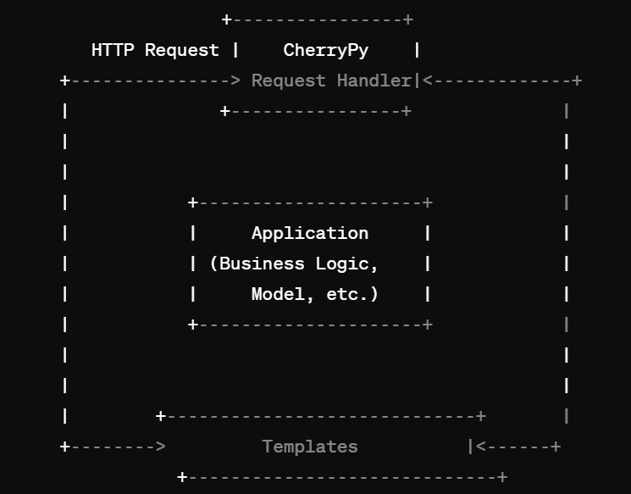

This diagram illustrates a basic CherryPy application architecture, where CherryPy handles incoming HTTP requests, routes them to appropriate request handlers, which in turn interact with the application logic (models, business logic), and render dynamic content using templates.

1. **Features and Functionality**

User Authentication and Authorization

CRUD Operations (Create, Read, Update, Delete)

RESTful API Endpoints

Session Management

Error Handling and Logging

1. **Challenges and Solutions** 
   1. **Modular Design:**

**Lesson:** Breaking the application into modular components improves maintainability and scalability.

**Best Practice:** Follow the MVC (Model-View-Controller) pattern to separate concerns and promote code reusability.

* 1. **Regular Updates and Maintenance:**

**Lesson:** Regularly updating CherryPy and its dependencies helps ensure compatibility with the latest security patches and performance improvements.

**Best Practice:** Establish a routine for updating dependencies and conduct code reviews to identify and address potential security vulnerabilities or performance issues.

* 1. **Documentation and Testing:**

**Lesson:** Comprehensive documentation and thorough testing are essential for building reliable and maintainable web applications.

**Best Practice:** Document codebase, APIs, and configurations. Adopt test-driven development (TDD) practices to ensure code quality and reliability.

1. **Future Improvements and Enhancements**
   1. **User Experience Enhancements:**

Implement responsive design to optimize the website for various devices and screen sizes. Introduce client-side scripting (e.g., JavaScript frameworks like React or Vue.js) for dynamic and interactive user interfaces.

* 1. **Performance Optimization:**

Integrate caching mechanisms (e.g., CherryPy's built-in caching or external caching solutions) to improve response times and reduce server load.

Optimize database queries and data retrieval processes to enhance overall application performance.

1. **Scalability and High Availability:**

Implement load balancing and horizontal scaling strategies to handle increased traffic and ensure high availability. Utilize containerization technologies (e.g., Docker) and orchestration platforms (e.g., Kubernetes) for easier deployment and management of application instances.

1. **Source Code:**
   1. **Front End**

In HTML format,

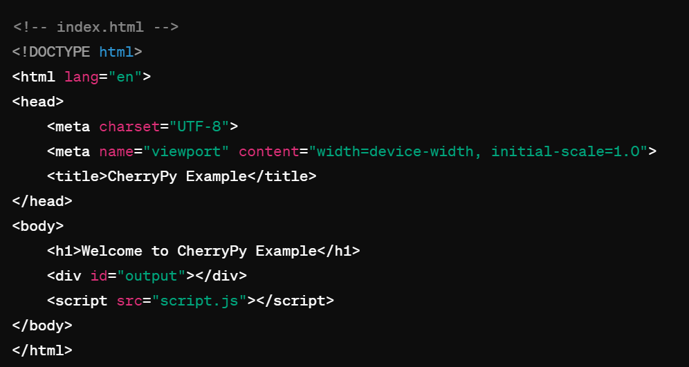

In CSS Format

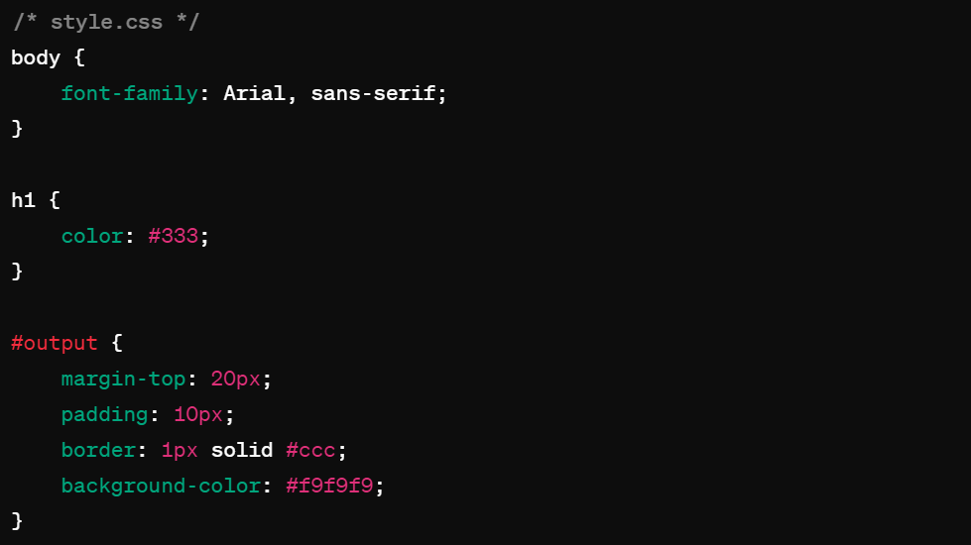

In JavaScript Format,

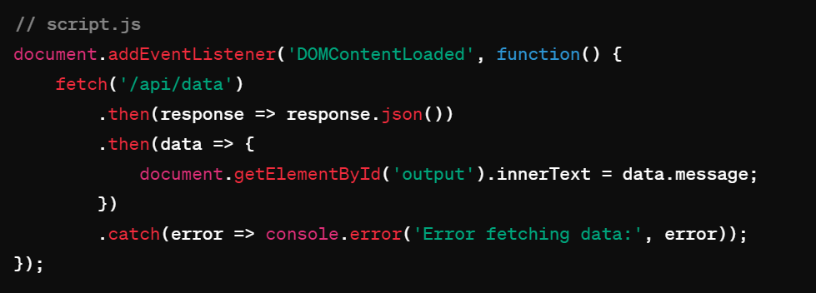

* 1. **Back End,**

In Python Format,

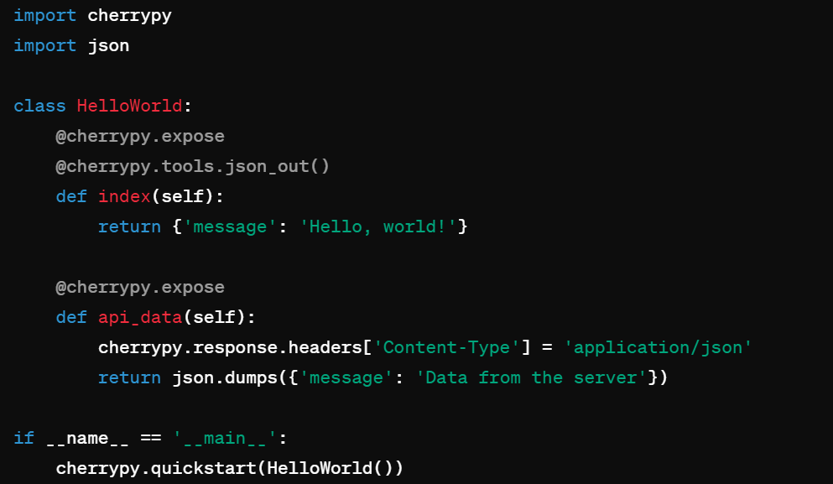

**How to Run:**

1. Make sure you have CherryPy installed (pip install cherrypy).
2. Save the front-end files (index.html, style.css, script.js) in a folder.
3. Save the back-end file (server.py) in the same folder.
4. Open a terminal, navigate to the folder, and run python server.py.
5. Open a web browser and visit http://localhost:8080 to see the result.
6. **Conclusion**

Throughout this presentation, we explored the use of CherryPy, a minimalist Python web framework, in the development of web applications.

We discussed its features such as modular design, flexibility, and built-in tools for handling HTTP requests and responses.

Case studies highlighted how CherryPy's simplicity and versatility make it an ideal choice for building scalable, maintainable, and secure web applications.

LinkedIn Profile: <https://www.linkedin.com/in/sneha-saravanan-0aa5b9232/>